**Application Module**

AngularJS supports modular approach. Modules are used to separate logics say services, controllers, application etc. and keep the code clean. We define modules in separate js files and name them as per the module.js file. In this example we're going to create two modules.

* **Application Module** − used to initialize an application with controller(s).
* **Controller Module** − used to define the controller.

Application Module

*mainApp.js*

var mainApp = angular.module("mainApp", []);

Here we've declared an application **mainApp** module using angular.module function. We've passed an empty array to it. This array generally contains dependent modules.

Controller Module

*studentController.js*

mainApp.controller("studentController", function($scope) {

$scope.student = {

firstName: "Mahesh",

lastName: "Parashar",

fees:500,

subjects:[

{name:'Physics',marks:70},

{name:'Chemistry',marks:80},

{name:'Math',marks:65},

{name:'English',marks:75},

{name:'Hindi',marks:67}

],

fullName: function() {

var studentObject;

studentObject = $scope.student;

return studentObject.firstName + " " + studentObject.lastName;

}

};

});

Here we've declared a controller **studentController** module using mainApp.controller function.

Use Modules

<div ng-app = "mainApp" ng-controller = "studentController">

...

<script src = "mainApp.js"></script>

<script src = "studentController.js"></script>

</div>

Here we've used application module using ng-app directive and controller using ng-controller directive. We've imported mainApp.js and studentController.js in the main html page.

Example

Following example will showcase all the above mentioned modules.

*testAngularJS.htm*

<html>

<head>

<title>Angular JS Modules</title>

<script src = "https://ajax.googleapis.com/ajax/libs/angularjs/1.3.14/angular.min.js"></script>

<script src = "/angularjs/src/module/mainApp.js"></script>

<script src = "/angularjs/src/module/studentController.js"></script>

<style>

table, th , td {

border: 1px solid grey;

border-collapse: collapse;

padding: 5px;

}

table tr:nth-child(odd) {

background-color: #f2f2f2;

}

table tr:nth-child(even) {

background-color: #ffffff;

}

</style>

</head>

<body>

<h2>AngularJS Sample Application</h2>

<div ng-app = "mainApp" ng-controller = "studentController">

<table border = "0">

<tr>

<td>Enter first name:</td>

<td><input type = "text" ng-model = "student.firstName"></td>

</tr>

<tr>

<td>Enter last name: </td>

<td><input type = "text" ng-model = "student.lastName"></td>

</tr>

<tr>

<td>Name: </td>

<td>{{student.fullName()}}</td>

</tr>

<tr>

<td>Subject:</td>

<td>

<table>

<tr>

<th>Name</th>

<th>Marks</th>

</tr>

<tr ng-repeat = "subject in student.subjects">

<td>{{ subject.name }}</td>

<td>{{ subject.marks }}</td>

</tr>

</table>

</td>

</tr>

</table>

</div>

</body>

</html>

*mainApp.js*

var mainApp = angular.module("mainApp", []);

*studentController.js*

mainApp.controller("studentController", function($scope) {

$scope.student = {

firstName: "Mahesh",

lastName: "Parashar",

fees:500,

subjects:[

{name:'Physics',marks:70},

{name:'Chemistry',marks:80},

{name:'Math',marks:65},

{name:'English',marks:75},

{name:'Hindi',marks:67}

],

fullName: function() {

var studentObject;

studentObject = $scope.student;

return studentObject.firstName + " " + studentObject.lastName;

}

};

});

Output

Open textAngularJS.htm in a web browser. See the result.

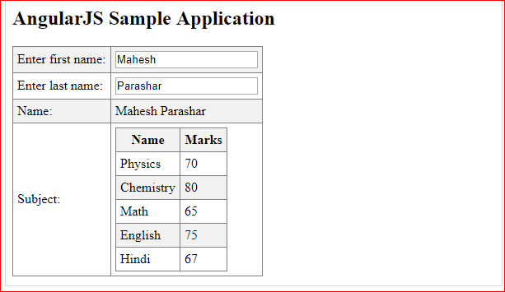

**Form**

AngularJS enriches form filling and validation. We can use ng-click to handle AngularJS click on button and use $dirty and $invalid flags to do the validations in seemless way. Use novalidate with a form declaration to disable any browser specific validation. Forms controls makes heavy use of Angular events. Let's have a quick look on events first.

Events

AngularJS provides multiple events which can be associated with the HTML controls. For example ng-click is normally associated with button. Following are supported events in Angular JS.

* ng-click
* ng-dbl-click
* ng-mousedown
* ng-mouseup
* ng-mouseenter
* ng-mouseleave
* ng-mousemove
* ng-mouseover
* ng-keydown
* ng-keyup
* ng-keypress
* ng-change

ng-click

Reset data of a form using on-click directive of a button.

<input name = "firstname" type = "text" ng-model = "firstName" required>

<input name = "lastname" type = "text" ng-model = "lastName" required>

<input name = "email" type = "email" ng-model = "email" required>

<button ng-click = "reset()">Reset</button>

<script>

function studentController($scope) {

$scope.reset = function(){

$scope.firstName = "Mahesh";

$scope.lastName = "Parashar";

$scope.email = "MaheshParashar@tutorialspoint.com";

}

$scope.reset();

}

</script>

Validate data

Following can be used to track error.

* **$dirty** − states that value has been changed.
* **$invalid** − states that value entered is invalid.
* **$error** − states the exact error.

Example

Following example will showcase all the above mentioned directives.

*testAngularJS.htm*

<html>

<head>

<title>Angular JS Forms</title>

<script src = "https://ajax.googleapis.com/ajax/libs/angularjs/1.3.14/angular.min.js"></script>

<style>

table, th , td {

border: 1px solid grey;

border-collapse: collapse;

padding: 5px;

}

table tr:nth-child(odd) {

background-color: #f2f2f2;

}

table tr:nth-child(even) {

background-color: #ffffff;

}

</style>

</head>

<body>

<h2>AngularJS Sample Application</h2>

<div ng-app = "mainApp" ng-controller = "studentController">

<form name = "studentForm" novalidate>

<table border = "0">

<tr>

<td>Enter first name:</td>

<td><input name = "firstname" type = "text" ng-model = "firstName" required>

<span style = "color:red" ng-show = "studentForm.firstname.$dirty && studentForm.firstname.$invalid">

<span ng-show = "studentForm.firstname.$error.required">First Name is required.</span>

</span>

</td>

</tr>

<tr>

<td>Enter last name: </td>

<td><input name = "lastname" type = "text" ng-model = "lastName" required>

<span style = "color:red" ng-show = "studentForm.lastname.$dirty && studentForm.lastname.$invalid">

<span ng-show = "studentForm.lastname.$error.required">Last Name is required.</span>

</span>

</td>

</tr>

<tr>

<td>Email: </td><td><input name = "email" type = "email" ng-model = "email" length = "100" required>

<span style = "color:red" ng-show = "studentForm.email.$dirty && studentForm.email.$invalid">

<span ng-show = "studentForm.email.$error.required">Email is required.</span>

<span ng-show = "studentForm.email.$error.email">Invalid email address.</span>

</span>

</td>

</tr>

<tr>

<td>

<button ng-click = "reset()">Reset</button>

</td>

<td>

<button ng-disabled = "studentForm.firstname.$dirty &&

studentForm.firstname.$invalid || studentForm.lastname.$dirty &&

studentForm.lastname.$invalid || studentForm.email.$dirty &&

studentForm.email.$invalid" ng-click="submit()">Submit</button>

</td>

</tr>

</table>

</form>

</div>

<script>

var mainApp = angular.module("mainApp", []);

mainApp.controller('studentController', function($scope) {

$scope.reset = function(){

$scope.firstName = "Mahesh";

$scope.lastName = "Parashar";

$scope.email = "MaheshParashar@tutorialspoint.com";

}

$scope.reset();

});

</script>

</body>

</html>

Output

Open textAngularJS.htm in a web browser. See the result.

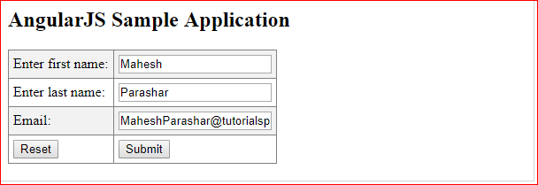

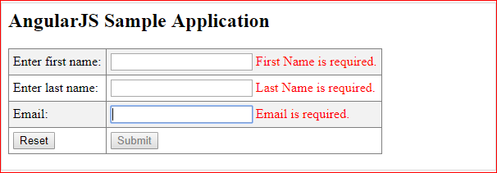

**Includes**

HTML does not support embedding html pages within html page. To achieve this functionality following ways are used −

* **Using Ajax** − Make a server call to get the corresponding html page and set it in innerHTML of html control.
* **Using Server Side Includes** − JSP, PHP and other web side server technologies can include html pages within a dynamic page.

Using AngularJS, we can embed HTML pages within a HTML page using ng-include directive.

<div ng-app = "" ng-controller = "studentController">

<div ng-include = "'main.htm'"></div>

<div ng-include = "'subjects.htm'"></div>

</div>

## Example

*tryAngularJS.htm*

<html>

<head>

<title>Angular JS Includes</title>

<script src = "https://ajax.googleapis.com/ajax/libs/angularjs/1.3.14/angular.min.js"></script>

<style>

table, th , td {

border: 1px solid grey;

border-collapse: collapse;

padding: 5px;

}

table tr:nth-child(odd) {

background-color: #f2f2f2;

}

table tr:nth-child(even) {

background-color: #ffffff;

}

</style>

</head>

<body>

<h2>AngularJS Sample Application</h2>

<div ng-app = "mainApp" ng-controller="studentController">

<div ng-include = "'/angularjs/src/include/main.htm'"></div>

<div ng-include = "'/angularjs/src/include/subjects.htm'"></div>

</div>

<script>

var mainApp = angular.module("mainApp", []);

mainApp.controller('studentController', function($scope) {

$scope.student = {

firstName: "Mahesh",

lastName: "Parashar",

fees:500,

subjects:[

{name:'Physics',marks:70},

{name:'Chemistry',marks:80},

{name:'Math',marks:65},

{name:'English',marks:75},

{name:'Hindi',marks:67}

],

fullName: function() {

var studentObject;

studentObject = $scope.student;

return studentObject.firstName + " " + studentObject.lastName;

}

};

});

</script>

</body>

</html>

*main.htm*

<table border = "0">

<tr>

<td>Enter first name:</td>

<td><input type = "text" ng-model = "student.firstName"></td>

</tr>

<tr>

<td>Enter last name: </td>

<td><input type = "text" ng-model = "student.lastName"></td>

</tr>

<tr>

<td>Name: </td>

<td>{{student.fullName()}}</td>

</tr>

</table>

*subjects.htm*

<p>Subjects:</p>

<table>

<tr>

<th>Name</th>

<th>Marks</th>

</tr>

<tr ng-repeat = "subject in student.subjects">

<td>{{ subject.name }}</td>

<td>{{ subject.marks }}</td>

</tr>

</table>

## Output

To run this example, you need to deploy textAngularJS.htm, main.htm and subjects.htm to a webserver. Open textAngularJS.htm using url of your server in a web browser. See the result.

